7.11 Main Question (สำหรับแสดงข้อสอบ)

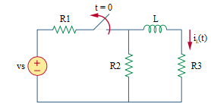

Given *vs* = 24 V, *R*1 = 4 Ω, *R*2 = 4 Ω, *R*3 = 8 Ω, *L* = 4 H.

Find

Variables (สำหรับเขียนโค้ดเพื่อหาคำตอบ)

Random variables

vs = {10:20};

r1 = {2:6:1};

r2 = {2:6:1};

r3 = {6:8:1};

l = {2:6:1};

time = {1:5};

Global variables

# vs = 24; r1 = 4; r2 = 4; r3 = 8; l = 4; time = 1;

# t = 0-

r12 = (r1*r2)/(r1+r2);

il0 = (r12/(r12+r3))*(vs/r1);

# t = 0+

tau = l/(r2+r3);

ilt = il0*exp(-time);

Part (กรอกคำตอบ)

1. *τ* = tau = 1/3 s

2. *iL*(0-) = il0 = 1.2 A

3. *iL*(0+) = il0 = 1.2 A

At *t* > 0

4. *iL*(*t*) = il0*exp(-t/tau) = 1.2*exp(-3t) A

5. *iL*(time*τ*) = ilt = 0.44 A

7.12

Main Question (สำหรับแสดงข้อสอบ)

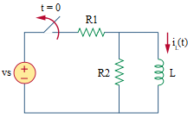

Given *vs* = 12 V, *R*1 = 3 Ω, *R*2 = 4 Ω, *L* = 2 H.

Find

Variables (สำหรับเขียนโค้ดเพื่อหาคำตอบ)

Random variables

vs = {10:20};

r1 = {1:5:1};

r2 = {2:6:1};

l = {1:3:0.5};

time = {1:5};

Global variables

# vs = 12; r1 = 3; r2 = 4; l = 2; time = 1;

il0 = v/r1;

tau = l/r2;

ilt = il0*exp(-time);

Part (กรอกคำตอบ)

1. *iL*(0-) = il0 = 4 A

2. *iL*(0+) = il0 = 4 A

3. *τ* = tau = 0.5 s

At *t* > 0

4. *iL*(*t*) = il0*exp(-t/tau) = 4*exp(-2t) A

5. *iL*(time*τ*) = ilt = 1.47 A

7.17

Main Question (สำหรับแสดงข้อสอบ)

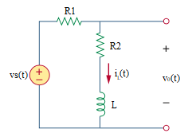

Given *iL*(0) = 6 A, vs(t) = 0 V, *R*1 = 1 Ω, *R*2 = 3 Ω, *L* = 0.25 H.

Find

Variables (สำหรับเขียนโค้ดเพื่อหาคำตอบ)

Random variables

vs = {10:20};

r1 = {1:5:1};

r2 = {1:5:1};

l = {0.25:1.25:0.25};

Global variables

# il0 = 6; vs = 0; r1 = 1; r2 = 3; l = 0.25;

tau = l/(r1+r2);

Part (กรอกคำตอบ)

1. *iL*(0-) = il0 = 6 A

2. *iL*(0+) = il0 = 6 A

3. *τ* = tau = 1/16 s

At *t* > 0

4. *iL*(*t*) = il0*exp(-t/tau) = 6*exp(-16t) A

5. *vo*(*t*) = (r2* il0*exp(-t/tau))+(l*(-1/tau)*il0*exp(-t/tau)) = -6*exp(-16t) V

7.18

Main Question (สำหรับแสดงข้อสอบ)

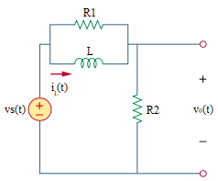

Given *iL*(0) = 5 A, *vs*(t) = 0 V, *R*1 = 2 Ω, *R*2 = 3 Ω, *L* = 0.4 H.

Find

Variables (สำหรับเขียนโค้ดเพื่อหาคำตอบ)

Random variables

vs = {10:20};

r1 = {1:5:1};

r2 = {1:5:1};

l = {0.1:0.5:0.1};

Global variables

# il0 = 5; vs = 0; r1 = 2; r2 = 3; l = 0.4;

tau = l/((r1*r2)/ (r1+r2));

Part (กรอกคำตอบ)

1. *iL*(0-) = il0 = 5 A

2. *iL*(0+) = il0 = 5 A

3. *τ* = tau = 1/3 s

At *t* > 0

4. *iL*(*t*) = il0*exp(-t/tau) = 5*exp(-3t) A

5. *vo*(*t*) = -l*(-1/tau)*il0*exp(-t/tau) = 6*exp(-3t) V

7.22

Main Question (สำหรับแสดงข้อสอบ)

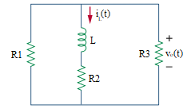

Given *iL*(0) = 10 A, *R*1 = 5 Ω, *R*2 = 1 Ω, *R*3 = 20 Ω, *L* = 2 H.

Find

Variables (สำหรับเขียนโค้ดเพื่อหาคำตอบ)

Random variables

vs = {10:20};

r1 = {3:7:1};

r2 = {1:5:1};

r3 = {18:22:1};

l ={1:3:0.5};

Global variables

# il0 = 10; r1 = 5; r2 = 1; r3 = 20; l = 2;

tau = l/((r1*r3/r1+r3)+r2);

Part (กรอกคำตอบ)

1. *iL*(0-) = il0 = 10 A

2. *iL*(0+) = il0 = 10 A

3. *τ* = tau = 2/5 s

At *t* > 0

4. *iL*(*t*) = il0*exp(-t/tau) = 10*exp(-2.5t) A

5. *vo*(t) = r3*(r1/(r1+r3))*(-il0*exp(-t/tau)) = -40*exp(-2.5t) V